**Finite State Machine**

**Definition:**

It is a computing machine (model) having fixed set of possible states, fixed set of inputs and outputs. New states depend on both current state and input value.

New State = Current State + Input Value

Finite State machines have limited memory.

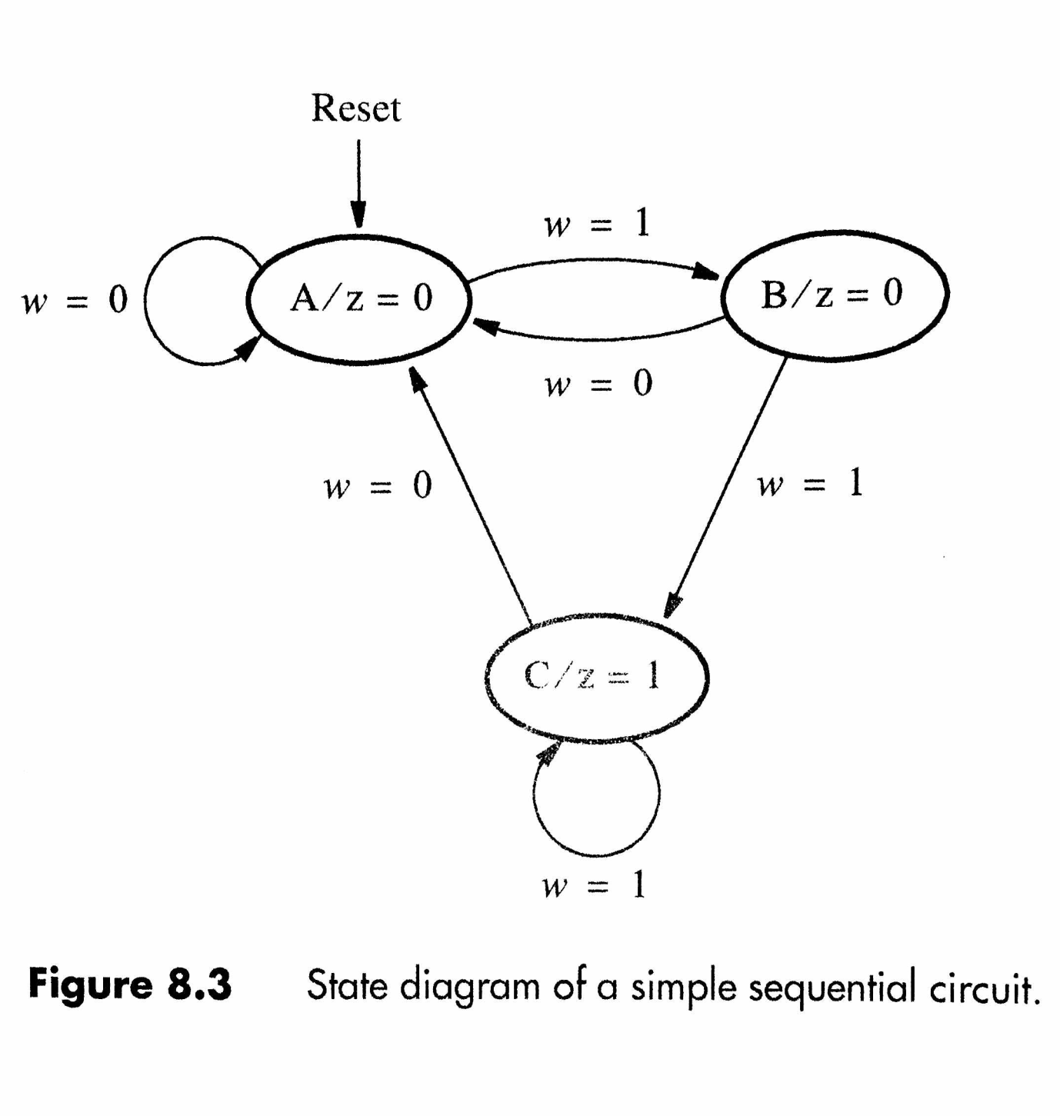

**Examples:**

**A Safe**

* *States*: Multiple "locked" states, one "unlocked" state
* *Transitions*: Correct combinations/keys move you from initial locked states to locked states closer to unlocked, until you finally get to unlocked. Incorrect combinations/keys land you back in the initial locked state.

**Traffic Light**

* *States*: RED, YELLOW, GREEN (simplest example)
* *Transitions*: After a timer change RED to GREEN, GREEN to YELLOW, and YELLOW to RED.

**Types:**

* With Output
  + - * Moore Machine
      * Mealy Machine
    - Without Output
      * Deterministic Finite Automata (DFA)
      * Non Deterministic Finite Automata (NDFA)
      * e-NDFA

**Parameters:**

Q: Set of all states

Σ: Inputs

Q0: Initial/Start state

F: Set of final states

T: Transitions between states.

**Transition Table:**

